Citizenship, Economics and Society (Secondary 1-3)
“3-minute Concept” Animated Video Clips Series:
“Media and Information Literacy”
Teaching Guidelines

1. Title of the animated video clip: “Media and Information Literacy”
2. Duration of the animated video clip: Around 3 minutes
3. Related CES module: Module1.1 Self-understanding and Life Skills
4. Introduction of the animated video clip: The animated video clip was developed by the Personal, Social and Humanities Education Section, Curriculum Development Institute, Education Bureau. It uses daily examples and simple language to succinctly explain the concept of “Media and Information Literacy”.
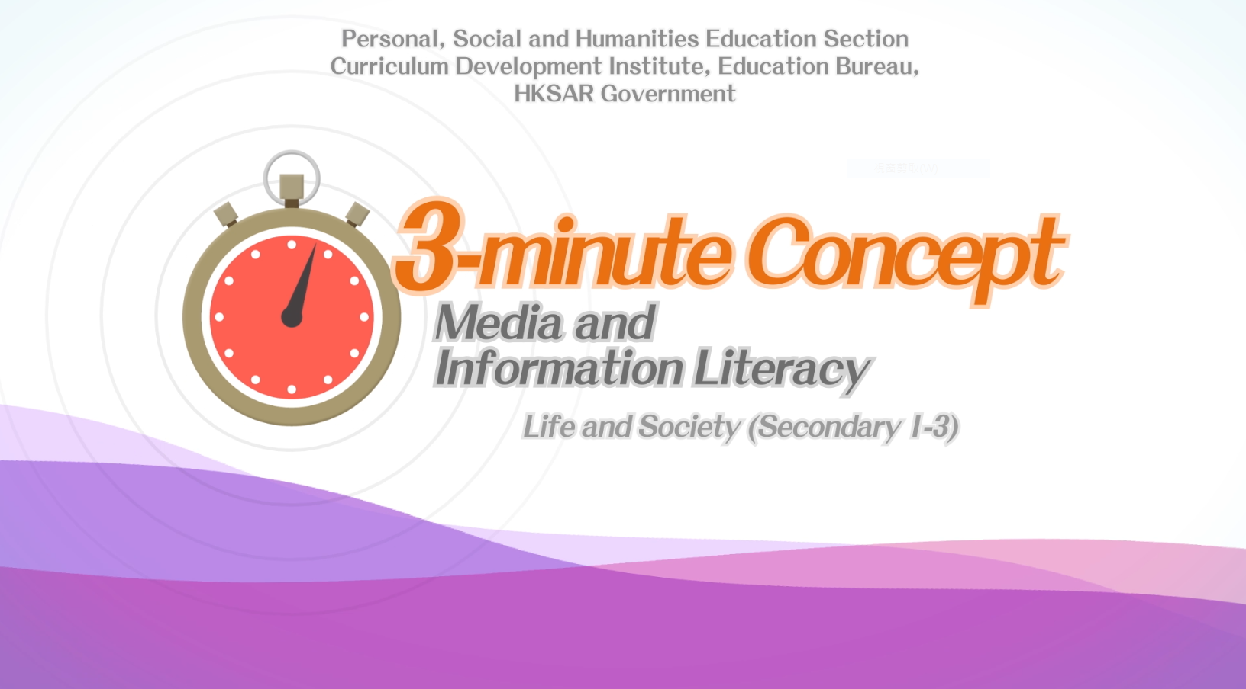
Citizenship, Economics and Society (Secondary 1-3)
Video link：
https://emm.edcity.hk/media/Life+and+Society+%223-minute+Concept%22+Animated+Video+Clips+SeriesA+%281%29+Media+and+Information+Literacy+%28English+subtitles+available%29/1_jo6df9fx
5. Teaching tips: Teachers must explain the following main points to students after playing the “Media and Information Literacy” animated video clip:
1) Visit credible media organisations for accurate, objective and impartial information | Teachers should point out to students that the cyber world is full of unverified and false information, some of which confuses right and wrong and distorts the facts, which can easily lead to misconceptions among immature adolescents and cause misunderstanding about society. Teachers should further advise students to obtain accurate, objective and impartial information from and make reference to the information provided by official bodies and organisations with high credibility. Teachers are suggested to refer to the following webpage when explaining to students how to obtain accurate, objective and impartial information :  香港教育城–網上資訊–難分真與假  (Chinese version only)  https://www.hkedcity.net/teencampus/resource/5ef309ac918e7fe21686f021
2) The cyber world is not without supervision and netizens are responsible for what they say and do on social media platforms | Teachers should point out to students that with the development of the Internet, more and more Internet users have become accustomed to sharing pictures of their lives, expressing their feelings and forwarding friends’ posts on social media platforms. Teachers should further point out to students that the cyber world is not a virtual world without supervision and that most laws targeting crime prevention in the real world also apply to the cyber world. Students should be cautious about what they say and do online, use media and information technology properly, safely, ethically and legally, and refrain from recklessly posting or forwarding unverified contents on social media platforms to avoid breaking the law inadvertently.
3) Be safe online and be aware of cyber crime | Teachers should point out to students that more and more criminals are reaching out to adolescents on social media platforms and discussion forums to trick them into engaging in illegal activities such as compensated dating and drug trafficking. Teachers should further point out to students that there are numerous online scams and that students should always be vigilant when making friends online and do not trust strangers lightly. At the same time, before making any online purchases, students should carefully and rationally review, analyse and assess the authenticity of related website contents and stop the transactions immediately if they have doubts about the online shopping websites. Teachers are suggested to refer to the following webpage when explaining cyber crimes to students:  Hong Kong Police Force - Cyber Security and Technology Crime  https://www.police.gov.hk/ppp_en/04_crime_matters/tcd/
4) Be aware of online privacy and do not engage in doxxing acts | - Teachers should point out to students that we easily leave many cyber footprints on the Internet, including browsing history, login information, photos, etc. Some criminals will use these personal data to conduct “online doxxing” and hold “public trial” of the target persons. Teachers should make it clear to students that online privacy is protected under the Personal Data (Privacy) Ordinance (PDPO) and that anyone who discloses another person’s privacy without their consent may be in breach of the PDPO and may be prosecuted by law enforcement agencies. Students must not engage in “doxxing” acts. Teachers are suggested to refer to the following webpage when explaining online privacy to students:  Office of the Privacy Commissioner for Personal Data, Hong Kong - The Personal Data (Privacy) Amendment Ordinance 2021  https://www.pcpd.org.hk/english/data_privacy_law/amendments_2021/amendment_2021.html

6. Consolidation questions : (See next page)

“3-minute Concept” Animated Video Clips Series:

“Media and Information Literacy”
Worksheet

A. Fill-in-the-blank Questions
Put the correct answers in the spaces provided.
Media and Information Literacy includes the ability to

Media and Information Literacy

B. True or False
Study the following sentences about “Media and Information Literacy”. Put a “T” in the blank for correct description and an “F” for incorrect description.
 | The media bring us a lot of convenience and fun. However, they also shape our values and our perception of things. | T
 | In an age when “speed”, “fun”, and “novelty” are stressed, all messages are thoroughly verified before they are distributed. | F
 | When we receive, use media messages or create media contents, we should “stop”, “look”, “listen” and “empathise”. | T

C. Short Questions
If we want the contents we create to be more valuable and attract more “likes”, what should we consider when creating media contents?
When creating media contents, we should consider other people’s
feelings by putting ourselves in their shoes.

The End

